**Lab Practice 6 – Database Systems (Joining)**

**Roll No: ________________ Name: __________________________________**

**Practice Question 1**

Write SQL query to show following output from **EMPLOYEES** and **DEPARTMENTS** tables using equi-join

**See output below**

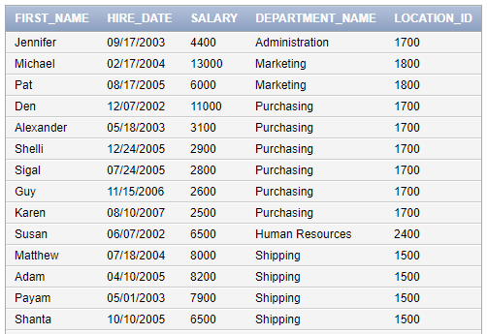

….

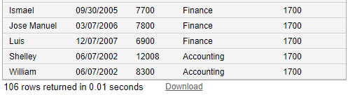

Answer: ____________________________________________________________________________________________________________________________________________________________________________________________________________________________________________________________________________________________________________________________________________________

**Practice Question 2**

Write SQL query to show following output from **EMPLOYEES, DEPARTMENTS** and **LOCATIONS** tables using **equi-join**

**See output below**

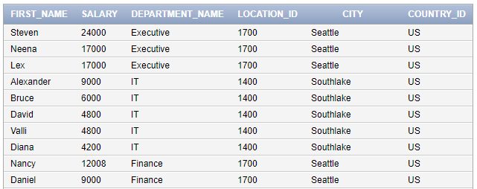

….

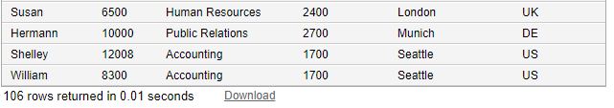

Answer: ______________________________________________________________________________________________________________________________________________________________________________________________________________________________________________________________________________________________________________________________________________________________________________________________________________________________________________________________________________________________________________________________

**Practice Question 3**

Write SQL query to show following output from **COUNTRIES** and **REGIONS** tables using **INNER JOIN**

**See output below** 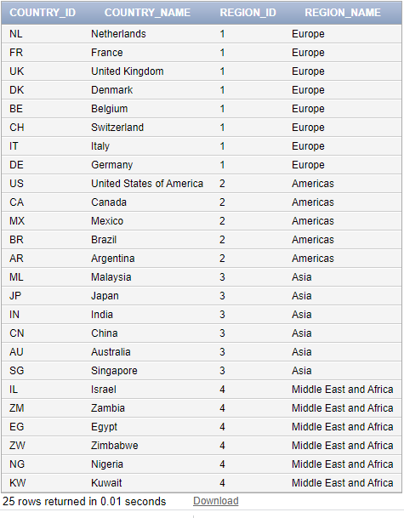

Answer: _________________________________________________________________________________________________________________________________________________________________________________________________________________________________________________________________________________________________________________________________________________________________________________________________________________________________________

**Practice Question 4**

Write SQL query to show following output from **LOCATIONS**, **COUNTRIES** and **REGIONS** tables using **INNER JOIN** (**hint: use two inner joins**)

**See output below** 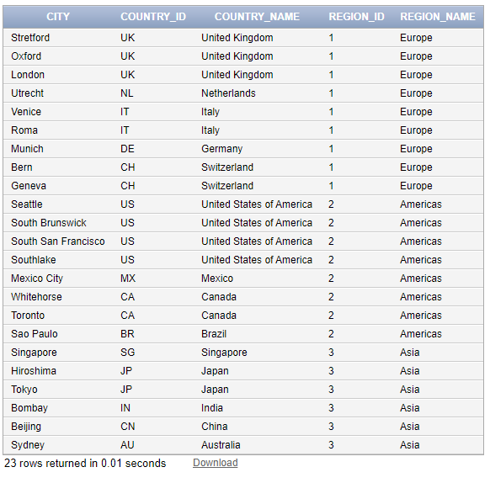

Answer: _______________________________________________________________________________________________________________________________________________________________________________________________________________________________________________________________

**Practice Question 5**

Write SQL query to do show **Cartesian Product** of **Employees**, **Departments** and **Locations** Tables.

See output below

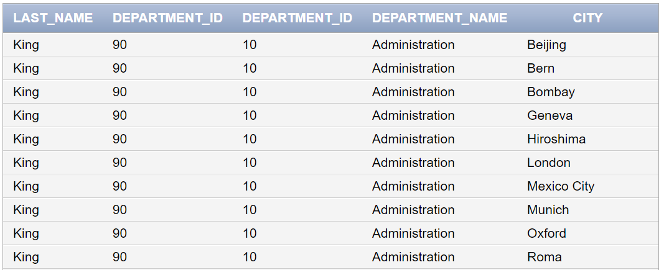

…

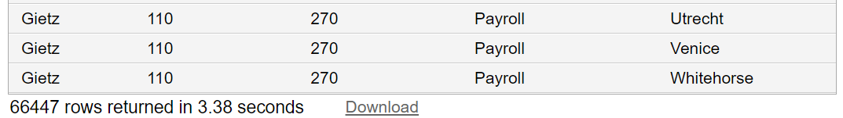

Answer: _________________________________________________________________________________________________________________________________________________________________________________________________________________________________________________________________________________________________________________________________________________________________________________________________________________________________________

**Practice Question 6**

Write SQL query to do show **Employee’s Last Names** whose name start with ‘**K**’ also show and **Department Names** against each name of employee

(Hint: Use Joining between **Employees** and **Departments** tables and also apply condition)

For details see output below

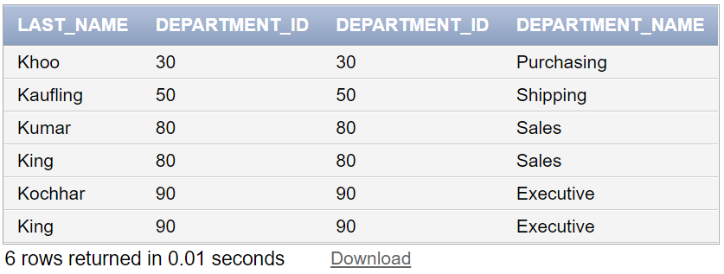

Answer: _________________________________________________________________________________________________________________________________________________________________________________________________________________________________________________________________________________________________________________________________________________________________________________________________________________________________________